Pseudo Code

Until month count = 12

Get Rainfall

Calculate and display Annual Rainfall

Calculate and display Mean Rainfall

Calculate and display Max Rainfall

Calculate and display Min Rainfall

**Compile Screenshot**

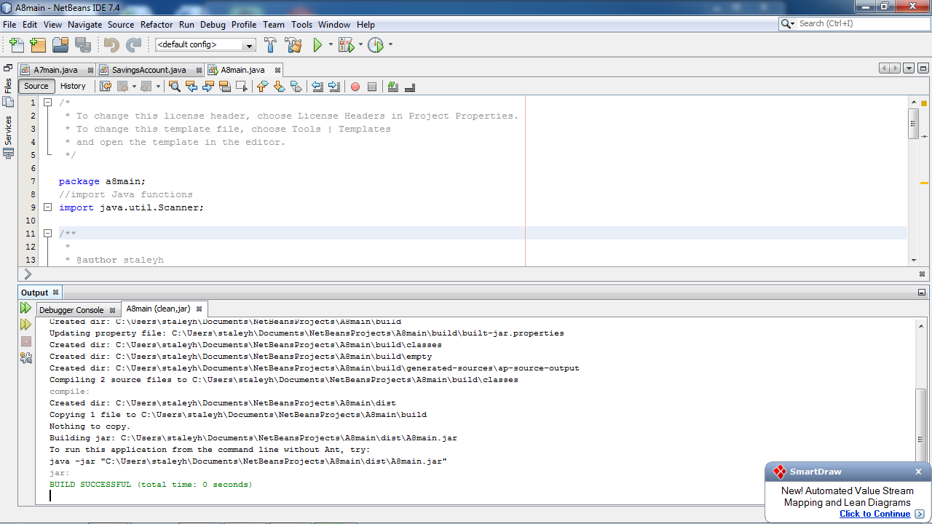

**Run Screenshot**

